Project Deliverables
- Gantt Chart for Project Tracking (Organized and managed by Mia)
- Organized and Categorized Product Listing
- Check-in meetings 2x per week with developing team

Preliminary Research
Local: Camcorp, VersaChem, Rentokil, Paramount
International: Dow, Sinopec, Luxi

Camcorp:
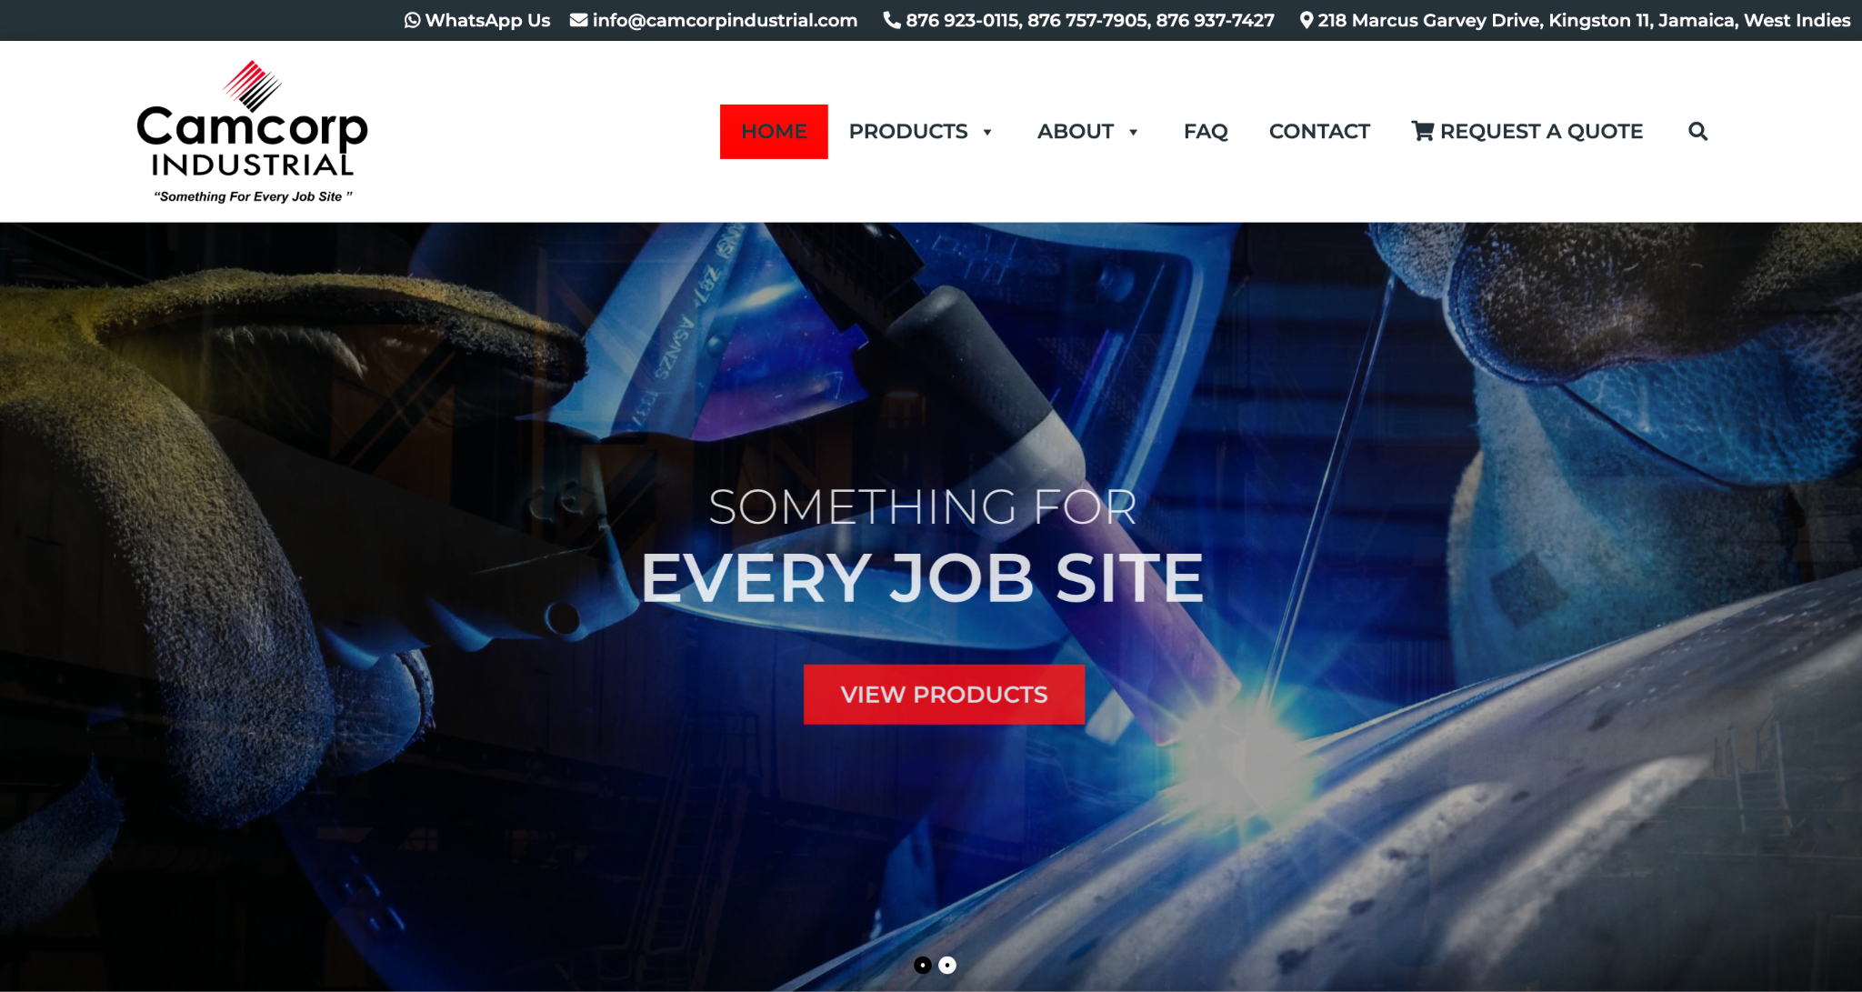
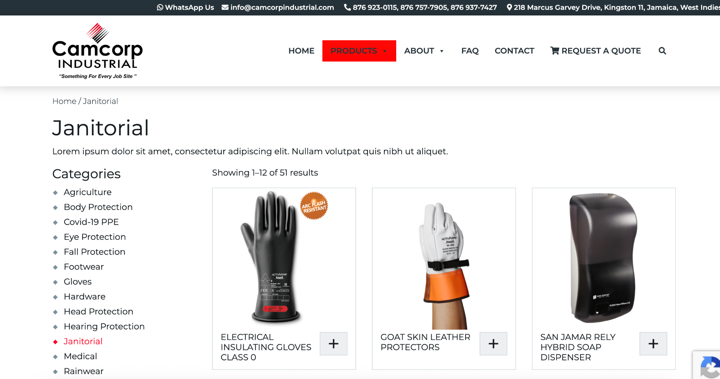
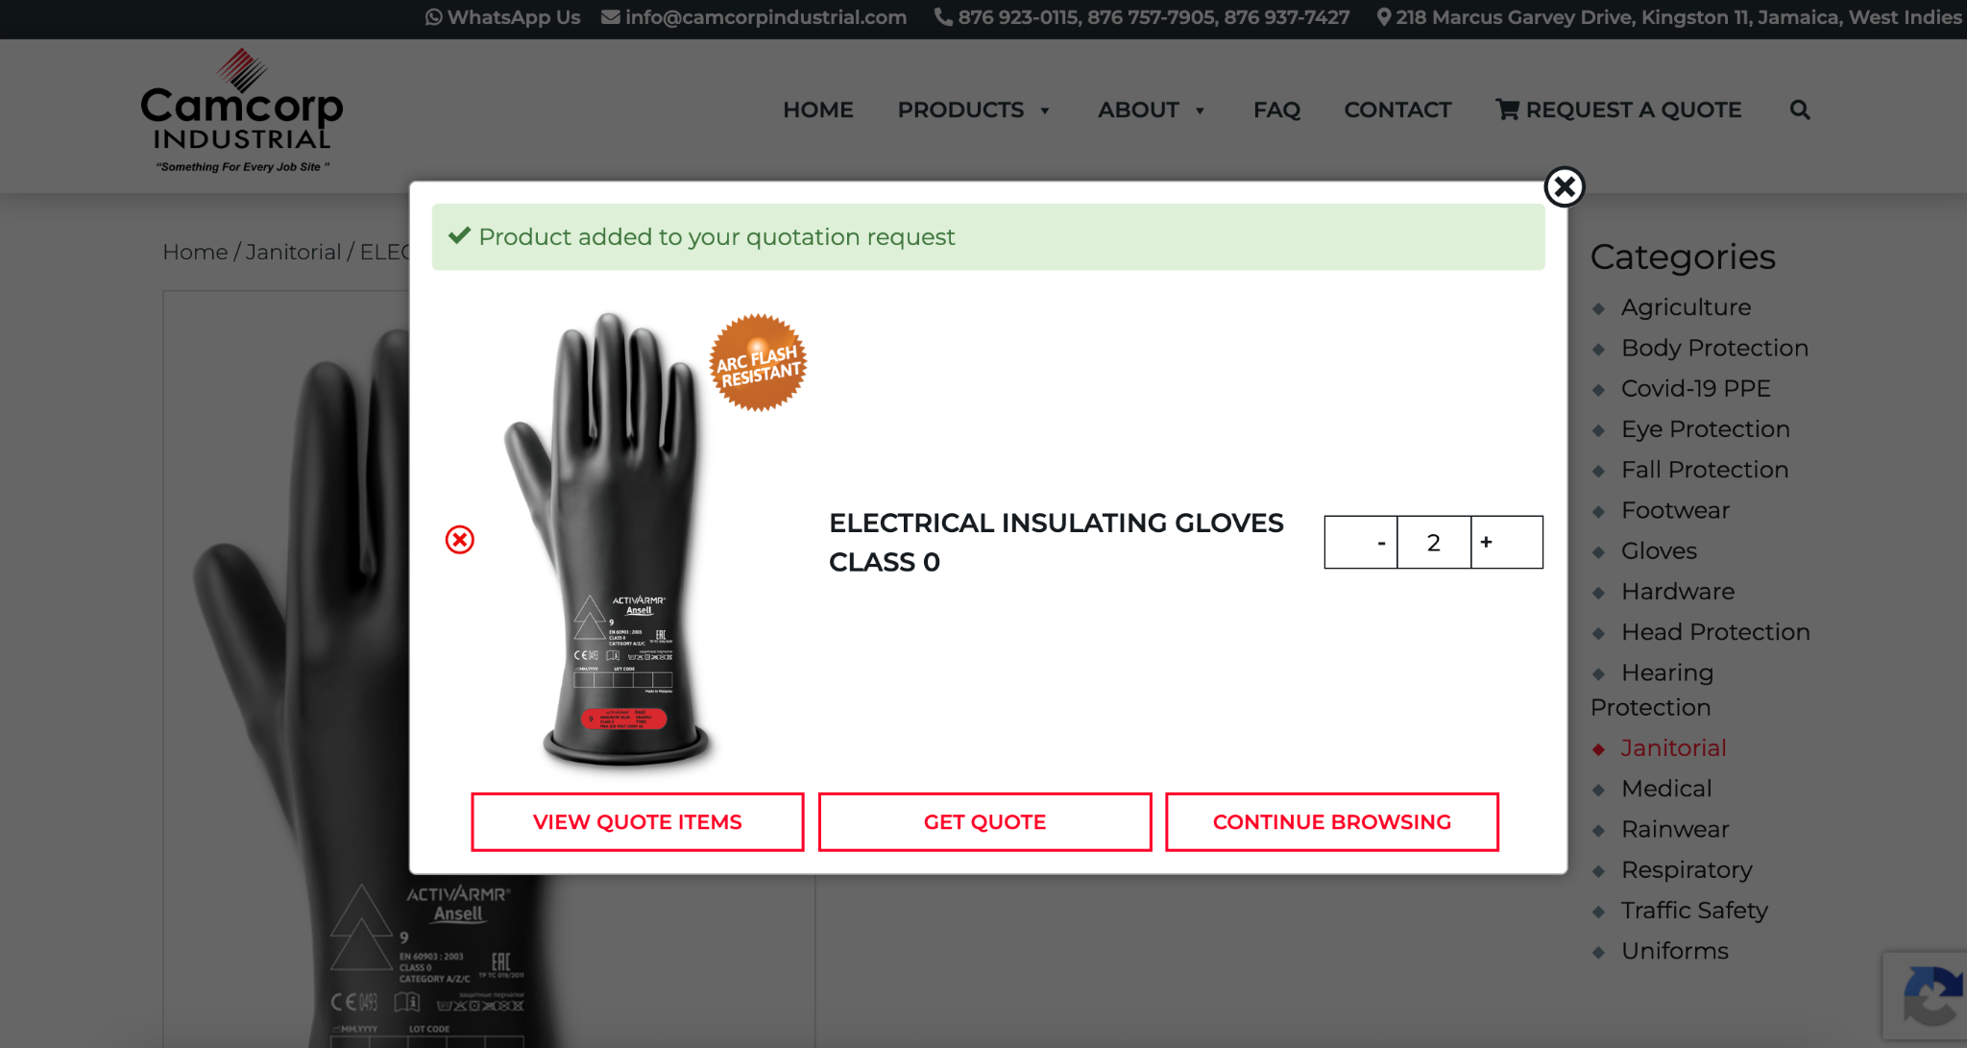
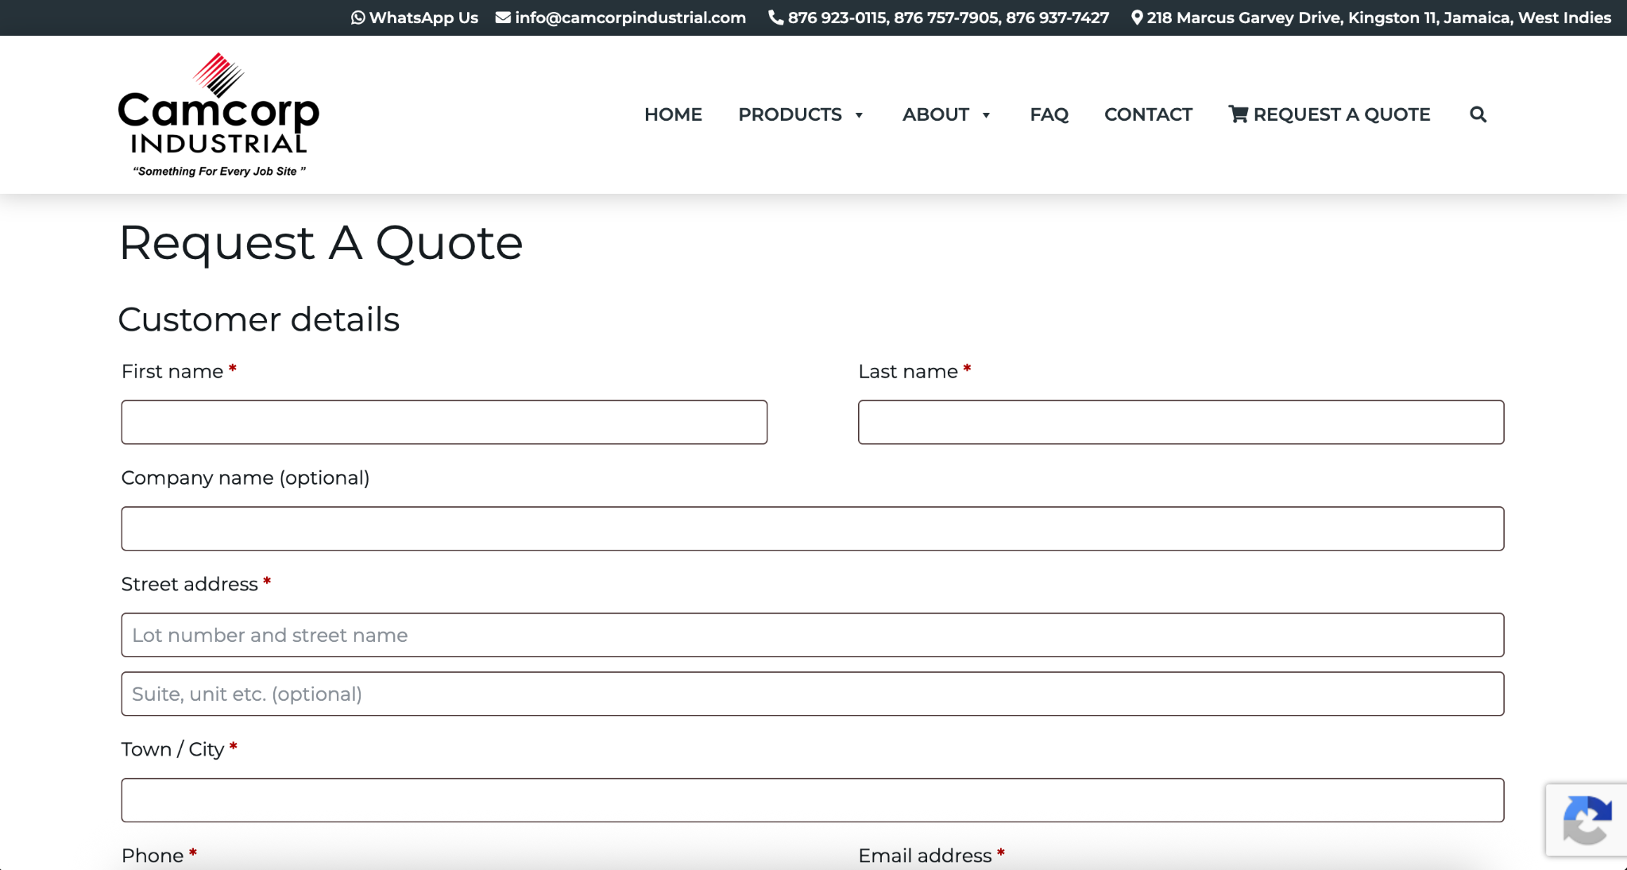
Notes: Most similar to desired transaction interface with items added to quote. Would improve the process by having a sign in for customers to avoid having to fill in information repetitively.

Versachem:
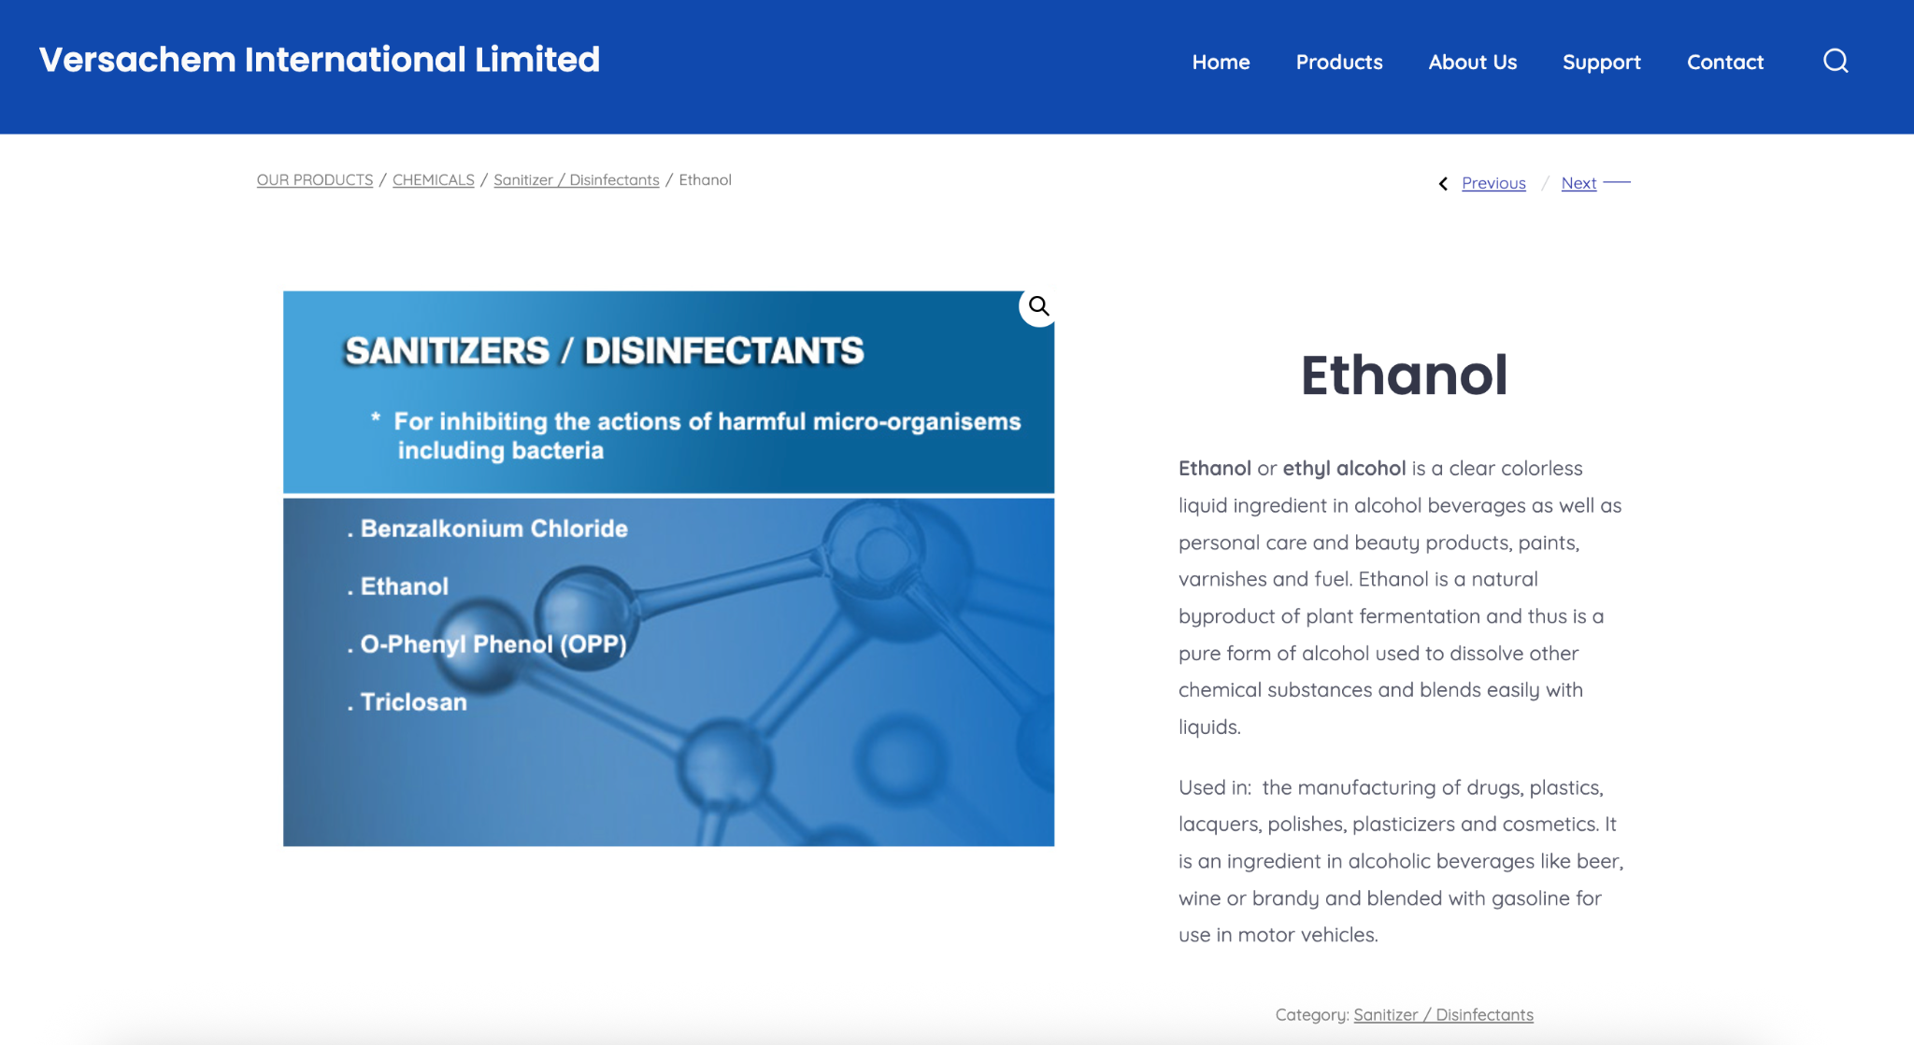
Notes - No online buying options, product listing available, no product pictures, very low quality UI

Rentokil:
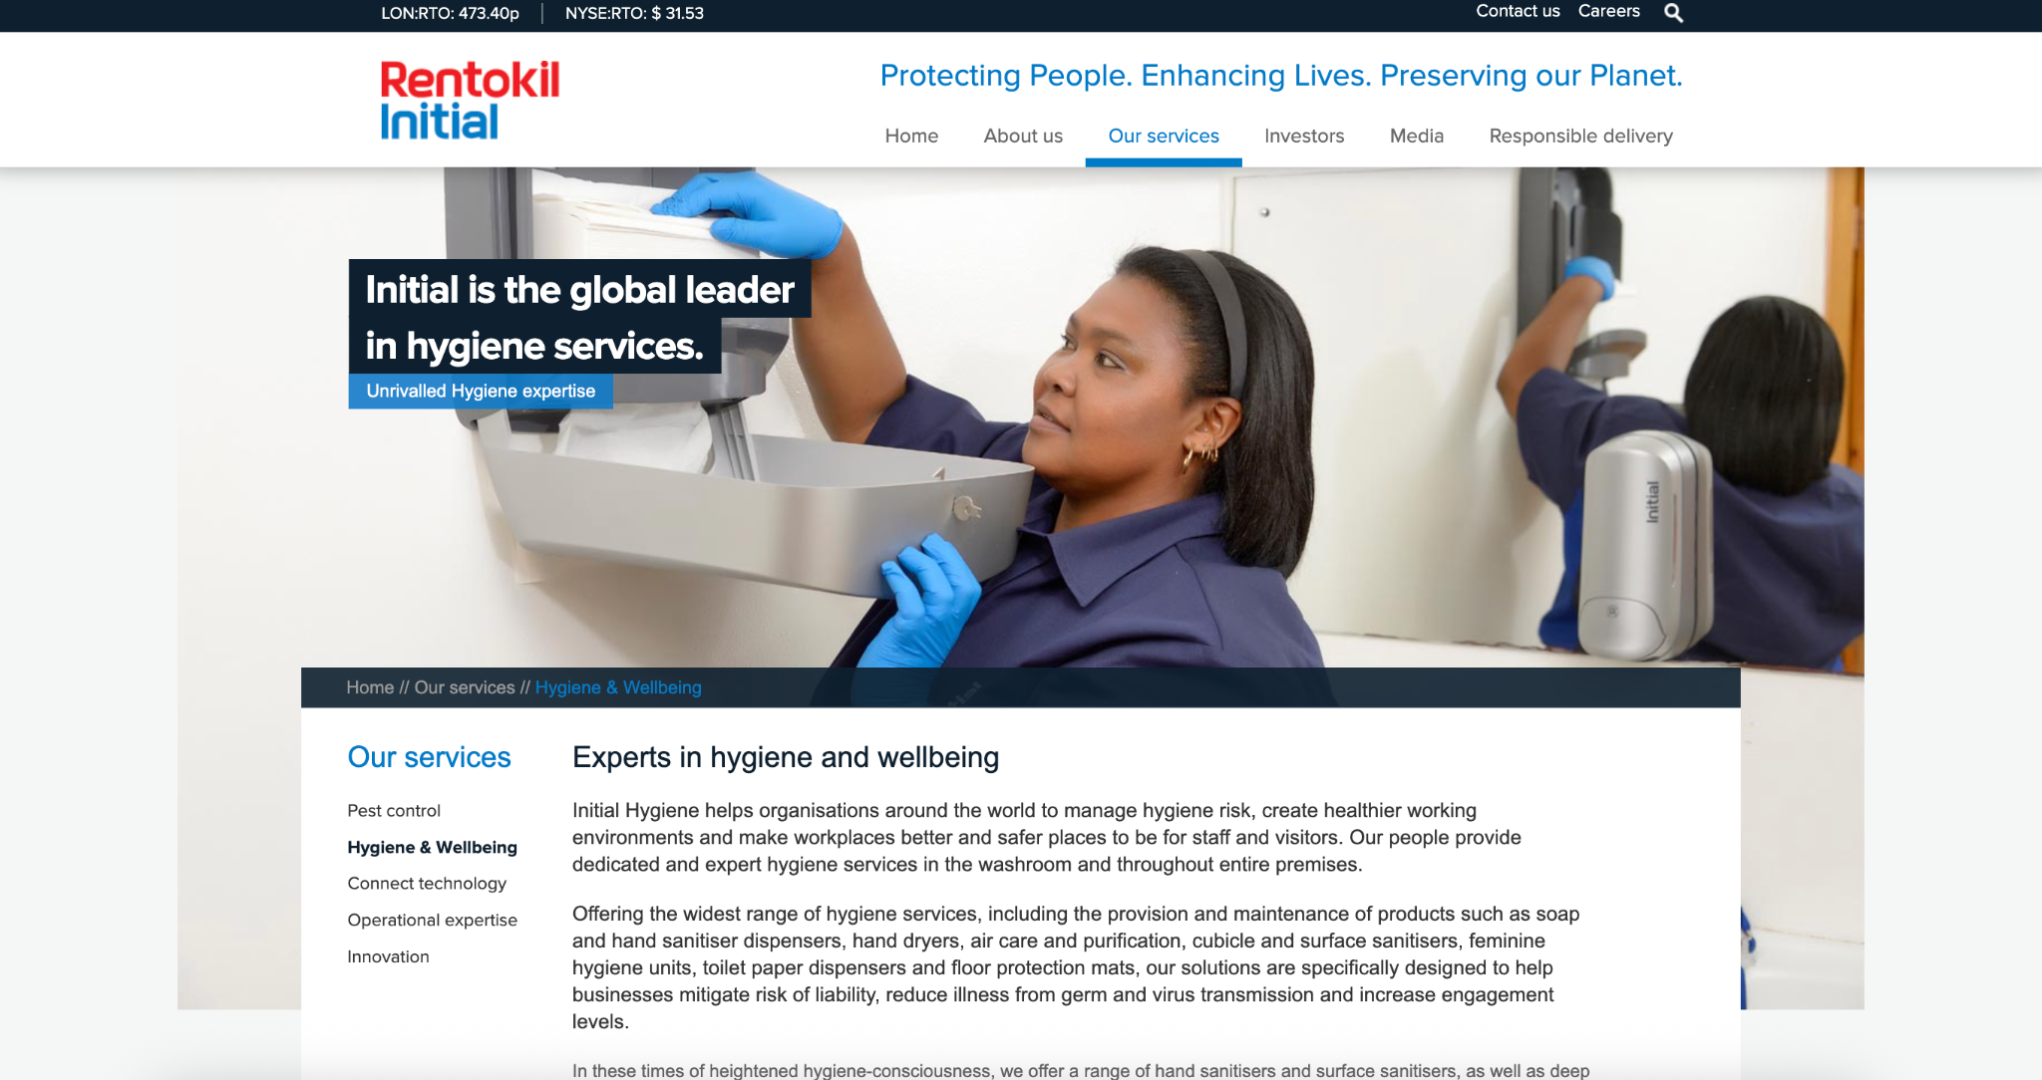
Notes - No online buying options, no product listing, too much to read, professional appearance of UI

Paramount:

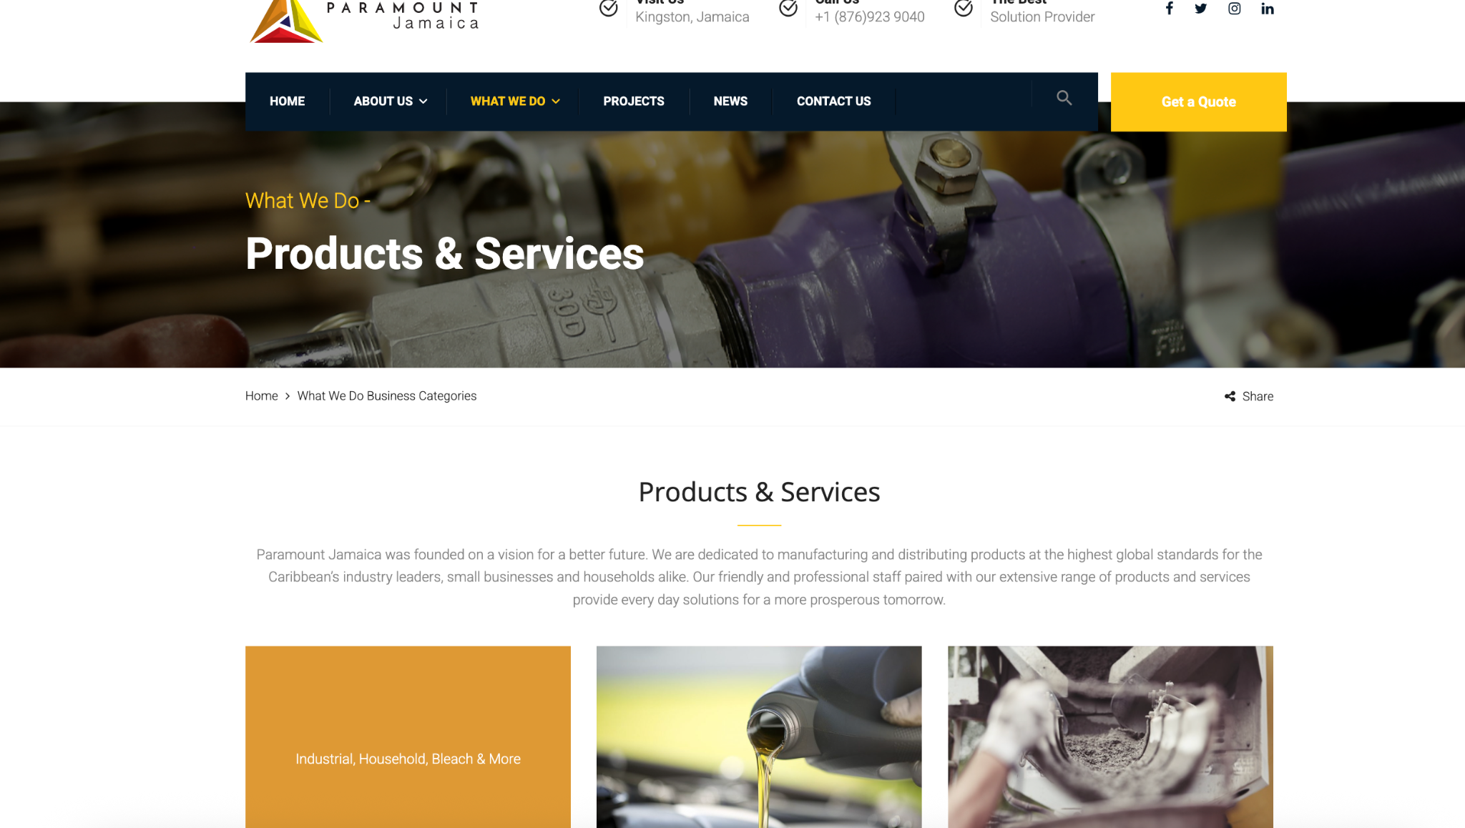
Notes - No online buying options, no product listing, Get a quote button helpful

Dow:
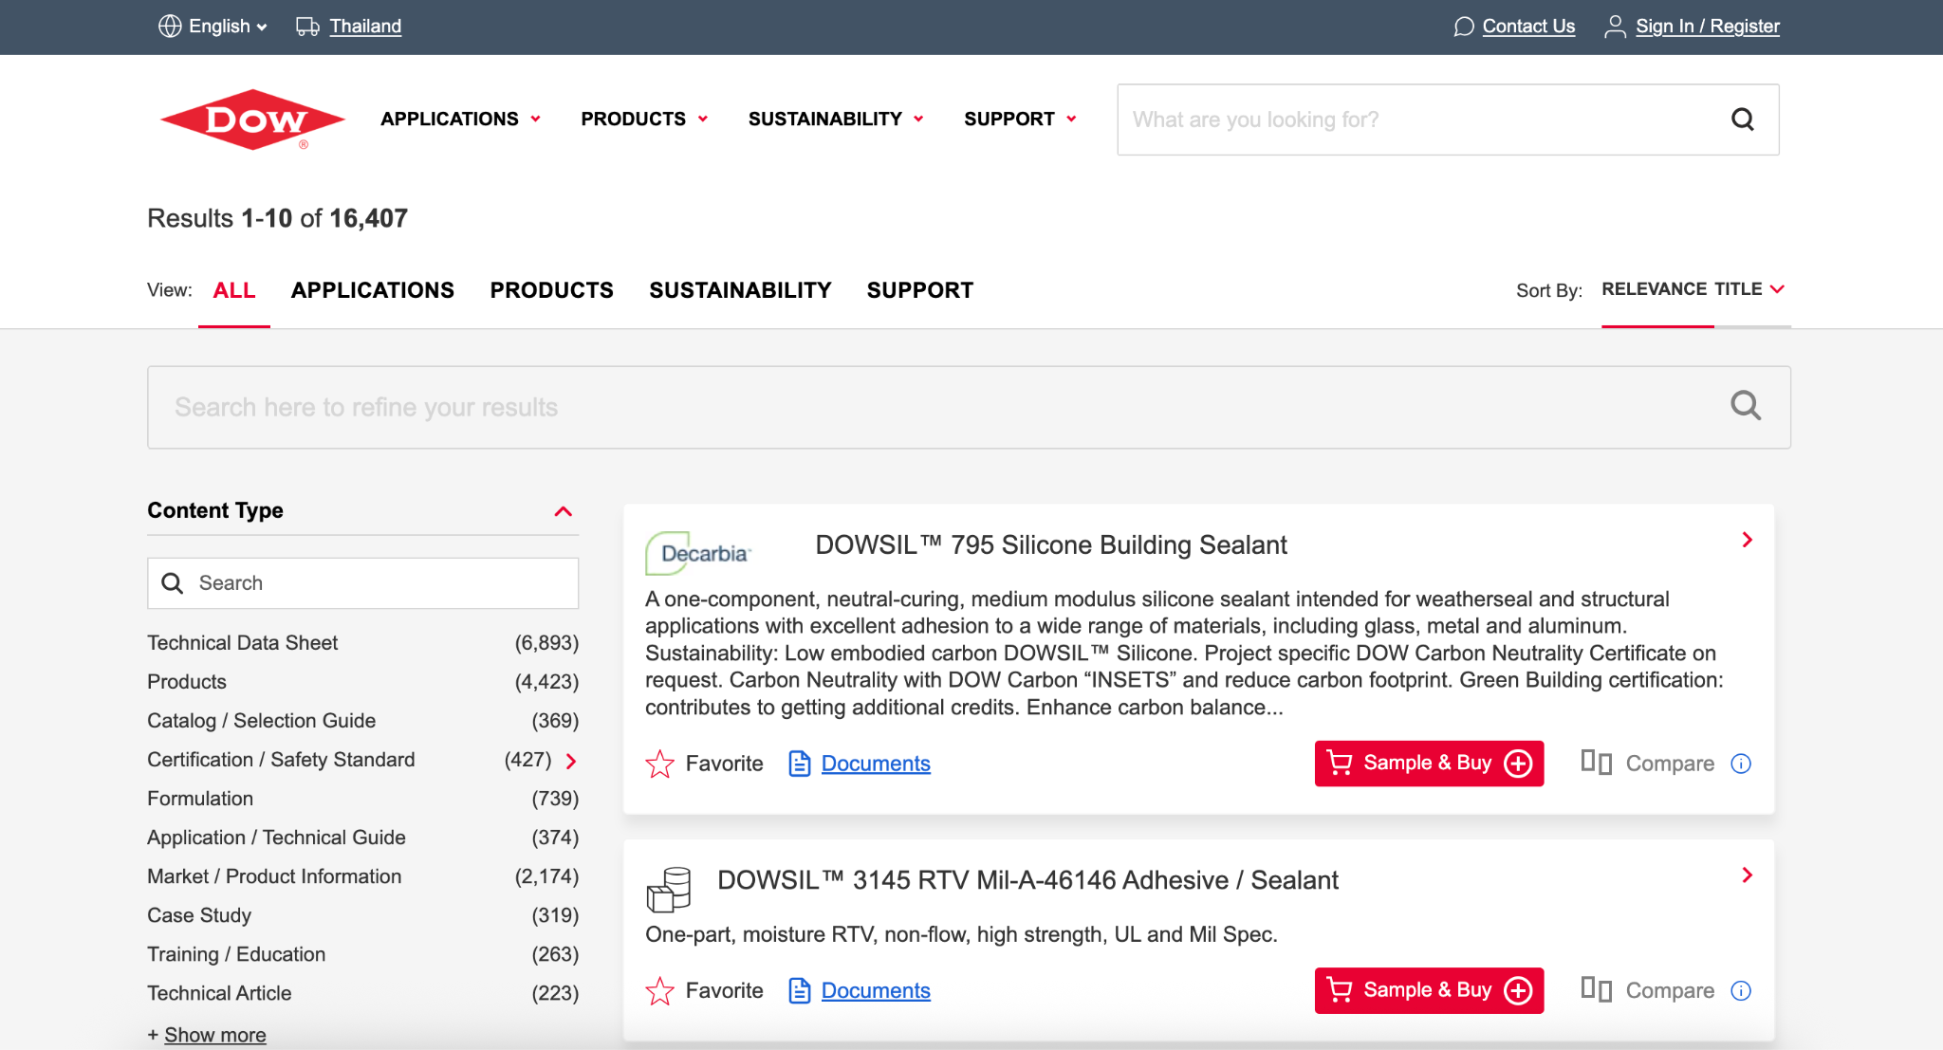
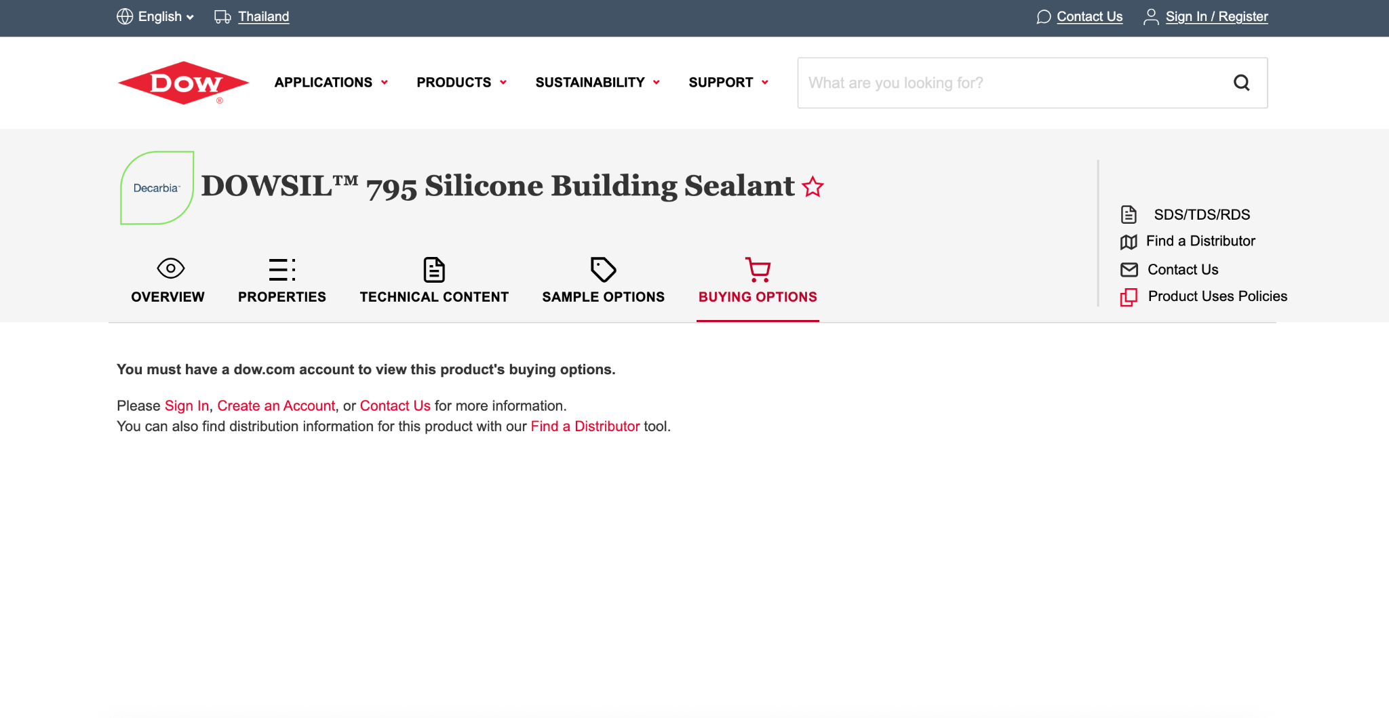
Notes: Best looking UI to draw inspiration from with sampling, SDS and available information

Luxi Chemicals:
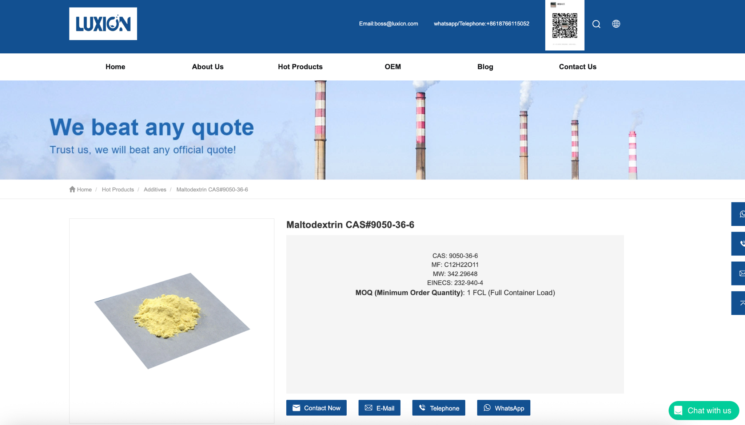
Notes: Interesting whatsapp option to consider
Website Design:
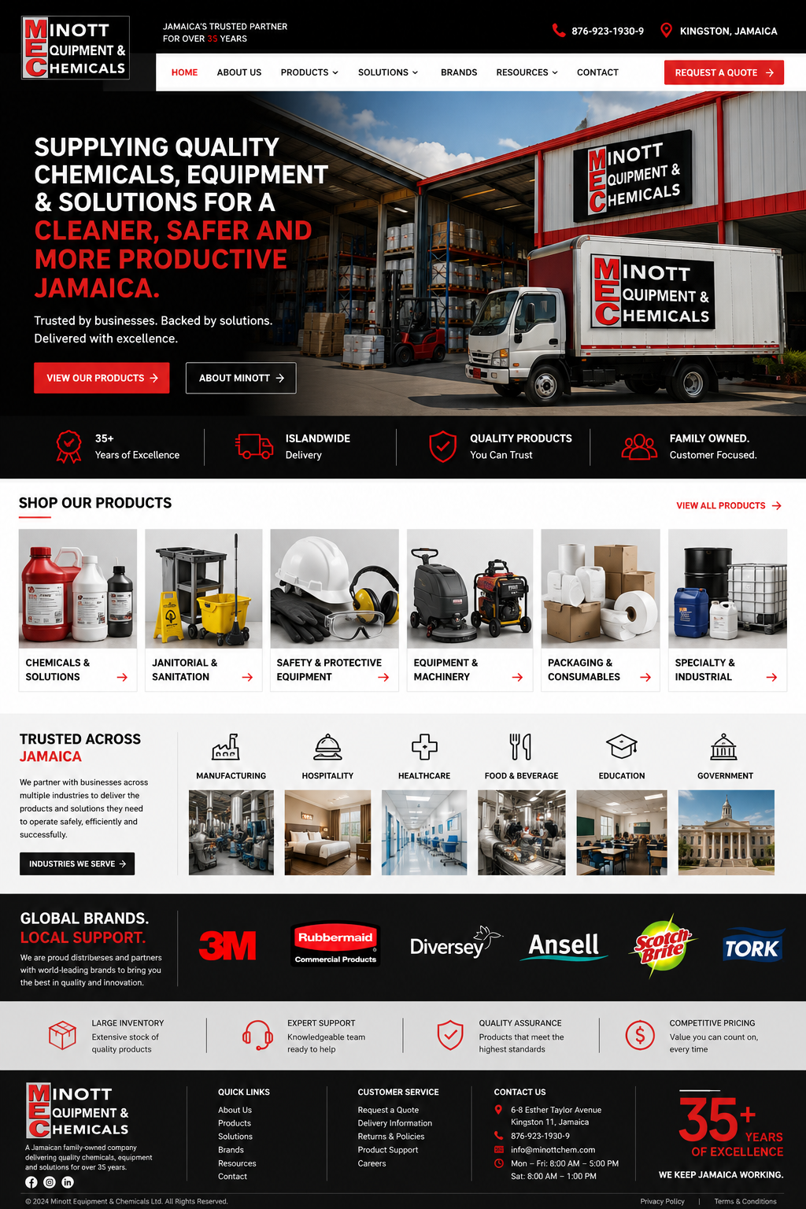
Notes: A simpler design would be sufficient. Desired tabs on top bar would be Home, About us, Products, Solutions, Social Responsibility and Contact
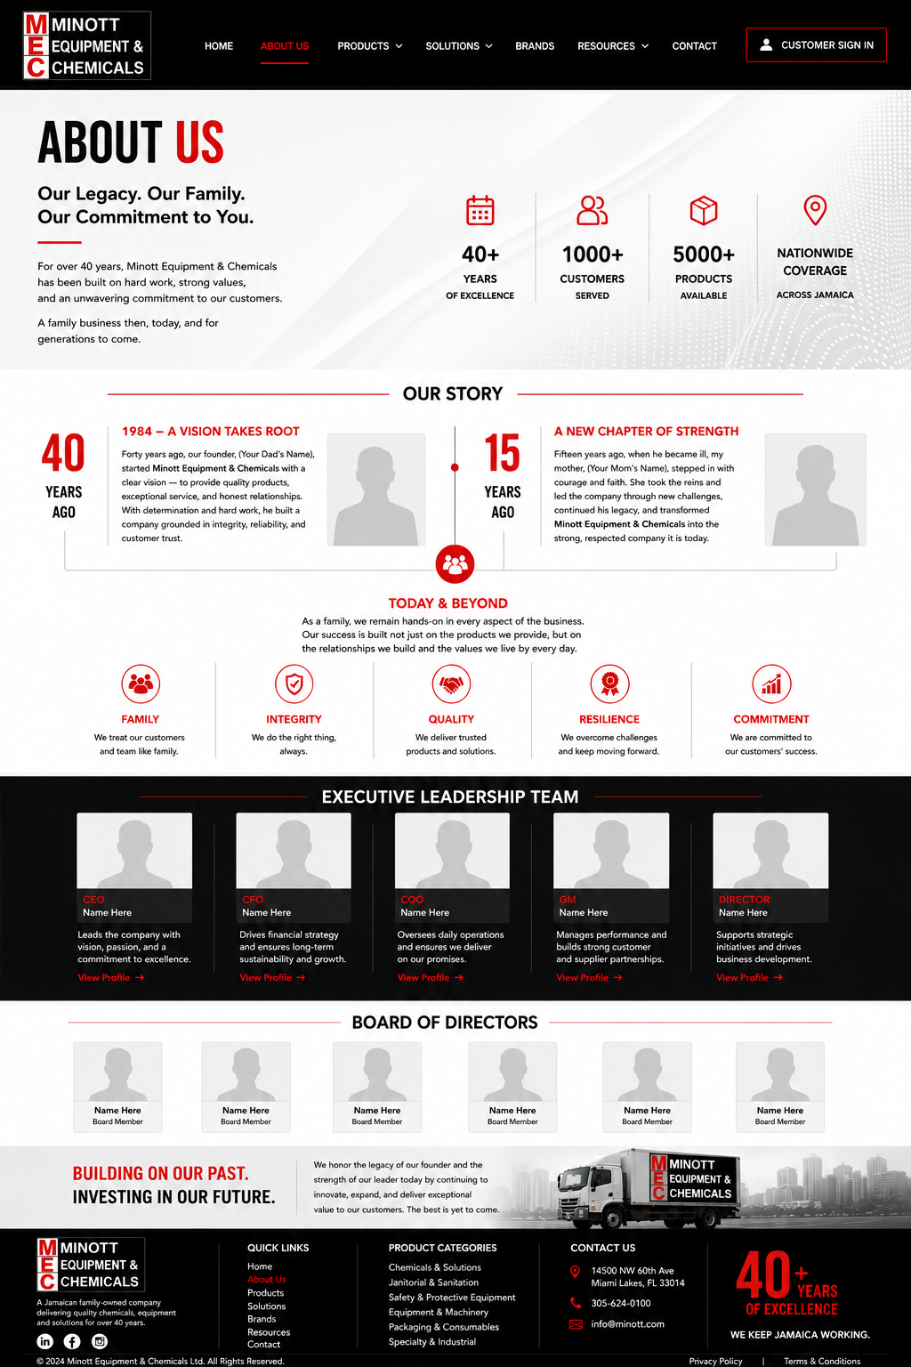
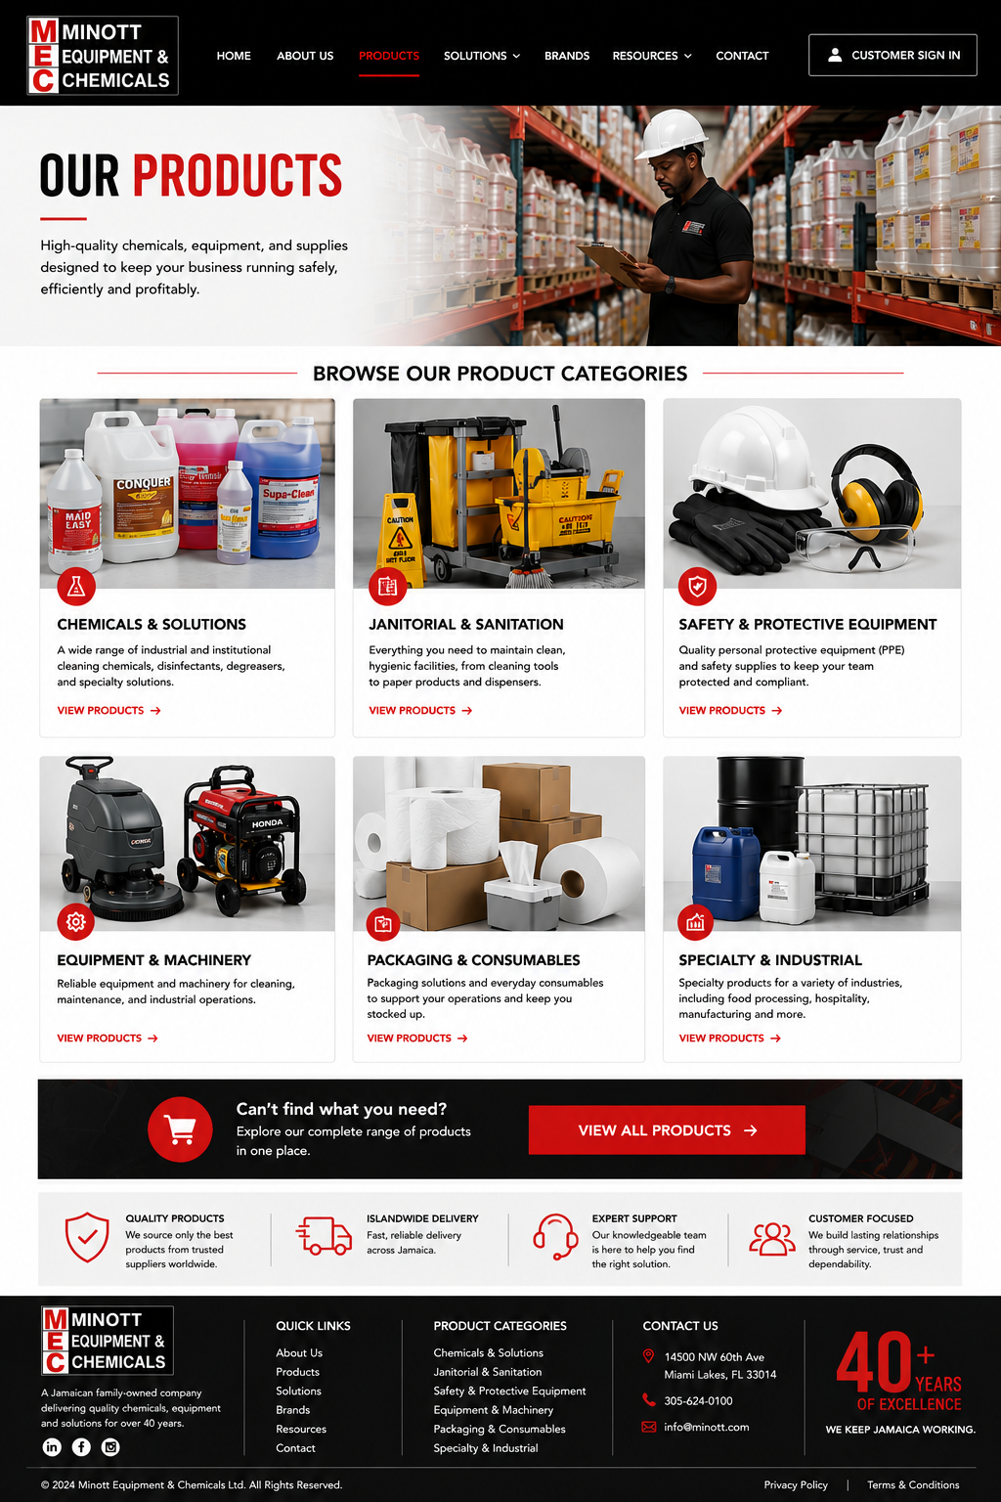

Notes: Would like a dropdown for the product categories when hovering over tab
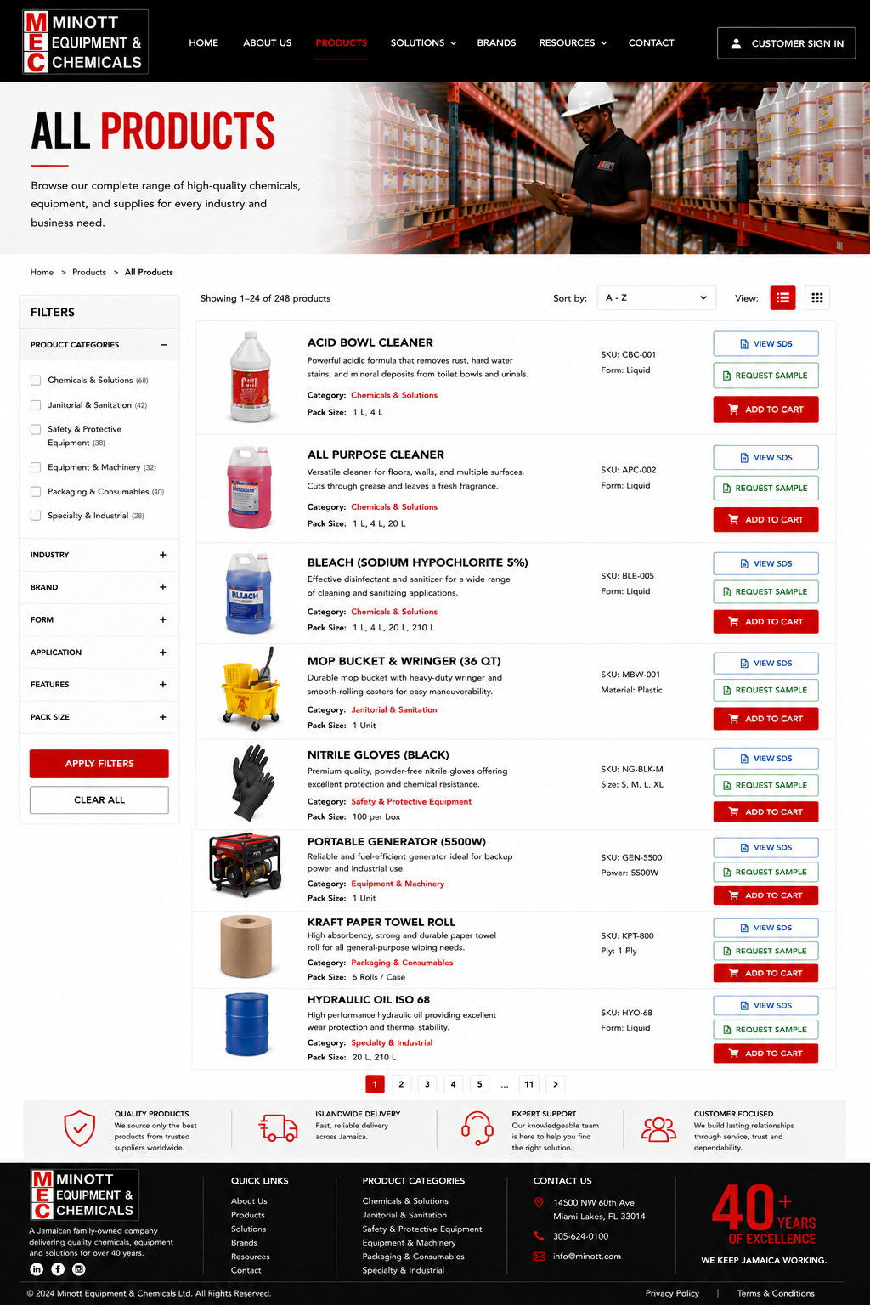
Notes: Only View SDS and Sample request buttons for chemicals. Add to quote instead of add to cart possibly like Camcorp’s process
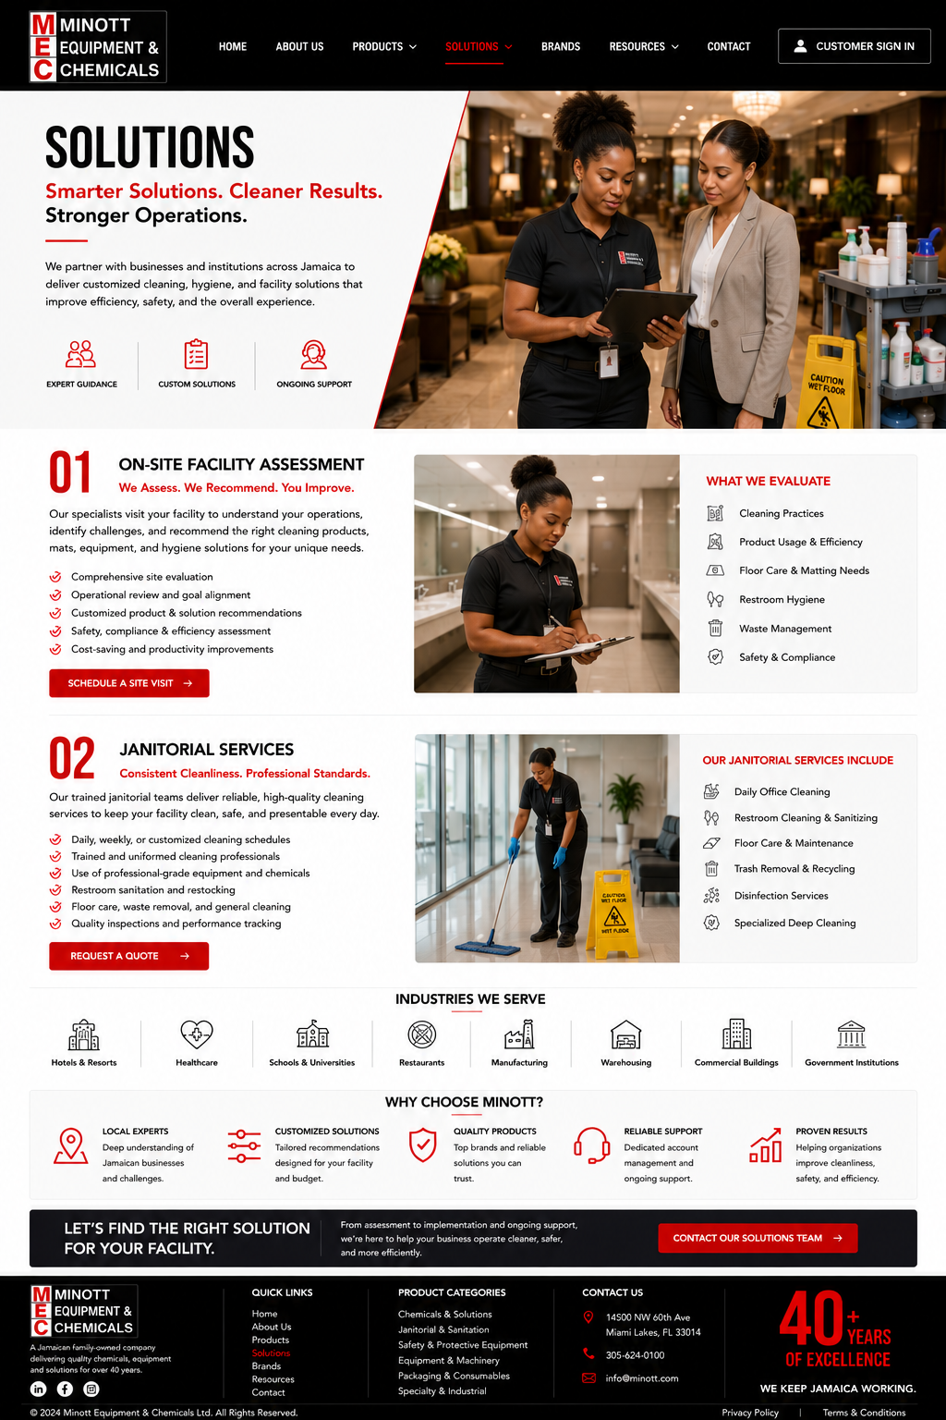
Notes:

